REVISION ENGLISH 3
UNIT 1+2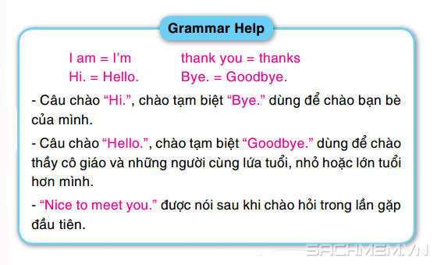
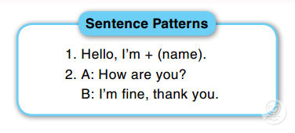
UNIT 3+4
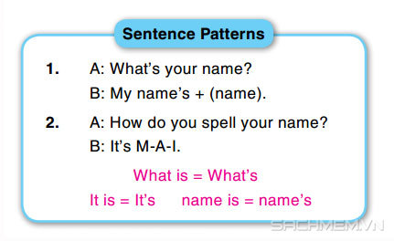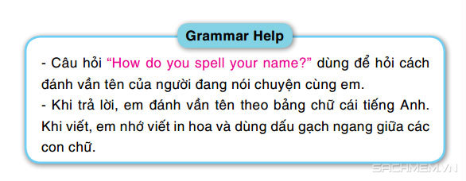

UNIT 5 + 6
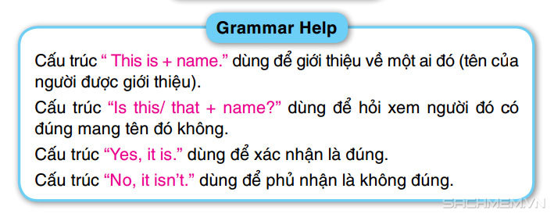
UNIT 7 + 8
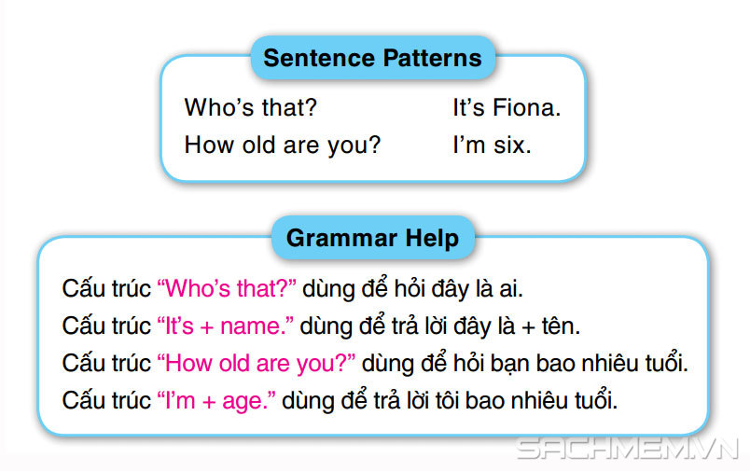
UNIT 9 + 10
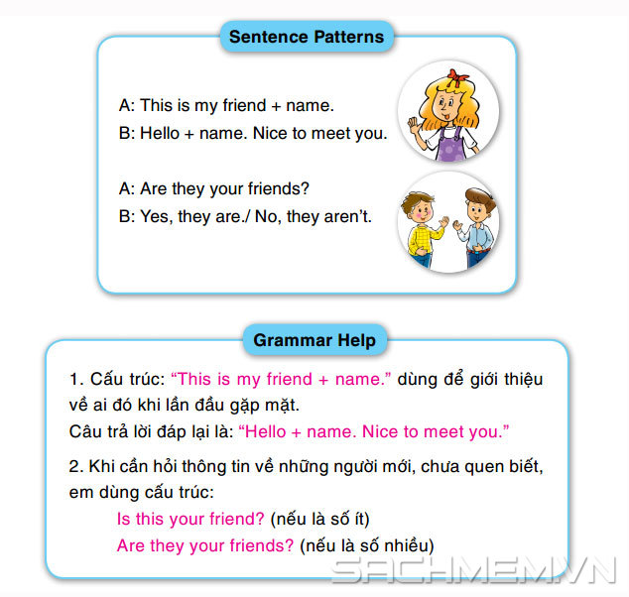

ENGLISH TEST 3
- Match and Write. Then Read the word aloud.
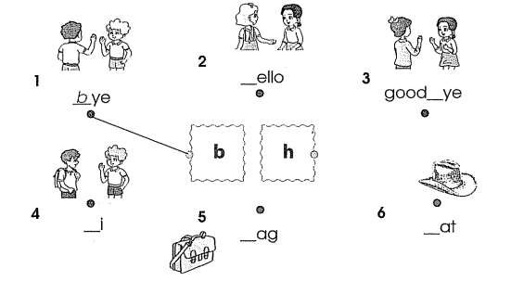
- Circle the word one out.
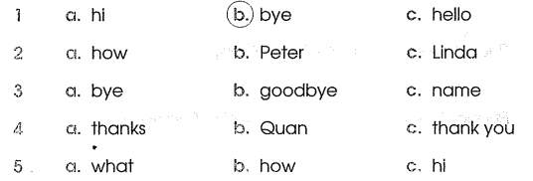
- Write
7. Reorder the following words to make sentence.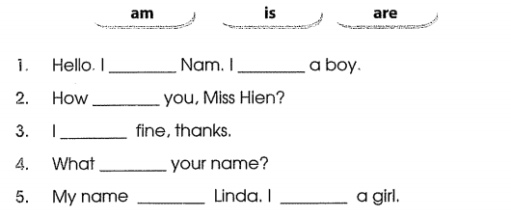
4. Reorder the following words to make sentence.
1. teacher/ Good/ morning/ ./
________________________________
2. I/ thanks./ fine,/ you?/ am/ And/
________________________________
3. her/ What/ name/ is/ ?/
________________________________
4. spell/ name,/ How/ do/ Linh/ you/ ?/ your/
________________________________
5. Ok/ you/ Are/ ?
5. Circle a or b
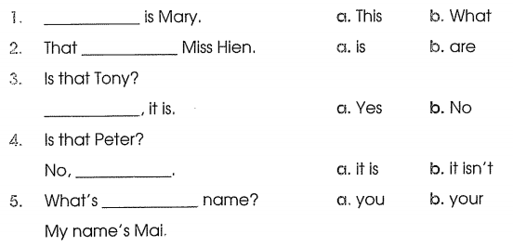
6. Read and match
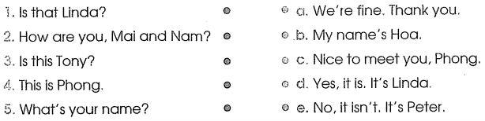
7. Read and write.
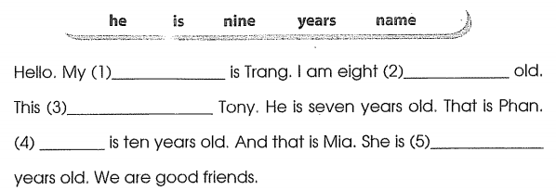
8. Read the text again and circle T or F.
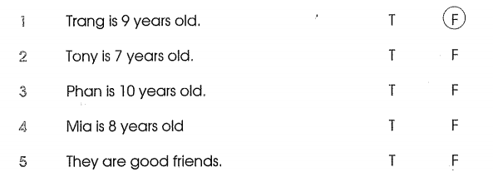
9. Circle a, b or c.
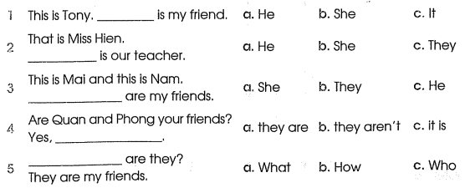
`10. Read and write.
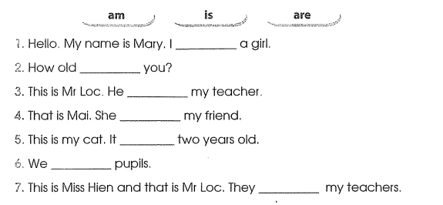
11. Match and Write. Then say the word aloud.
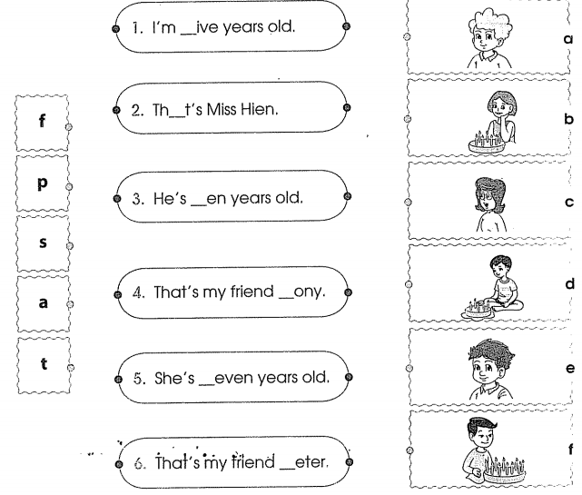
12. Read and write one word to each blank.
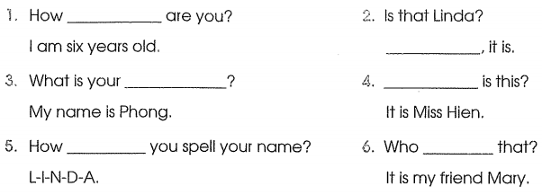
13. Put the words in order.
1. talk/ Don't/ and/ listen/ ./
______________________
2. play/ Let's/ football/ together/ .
______________________
3. my/ Linda/ This/ She/ is/ friend./ is/ ./
______________________
4. ask/ I/ May/ question/ a/ ?
______________________
5. out/ I/ May/ go/ ?/
______________________

14. Read and circle a, b or c.
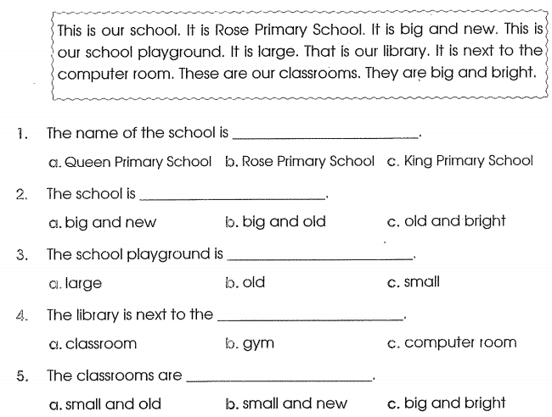
15. Circle the odd one out.
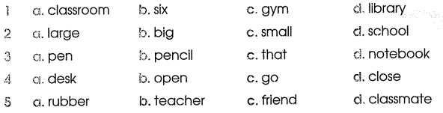
16. Read and fill the blanks.
This is the gym. It is big. This is the library. It is new and beautiful. That is the music room over there. It is small and old. I like the playground in my school because it is new and large.
1. The gym is _________
2. The library is ____________ and ___________
3. The music room is _______ and ________.
4. I like the ___________ in my school.
5. The playground is _________ and _______.

17. Read and colour.
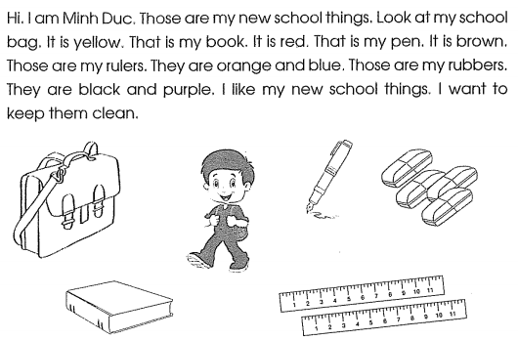
18. Read the text again and choose True or False.
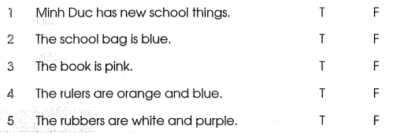

19. Read and write.
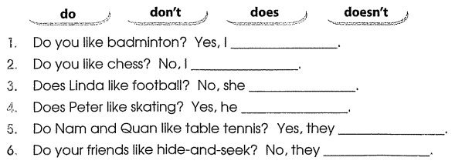
20. Read and write the name.
